Crushing mill

The crushing mill is a simple device which transforms the coffee beans to coffee powder. However, the process itself is very hard to model and would need some very complex 3D FEM analysis in order to accurately model the cracking of the beans. And maybe it is simply not possible today to simulate that process.  
For looking into the energy consumption of the coffee machine it is enough to model a rotational inertia with friction which is driven by a speed source or an electrical motor. The problem will be to parametrize the friction properly.  
This is the model I have built for the crushing mill.

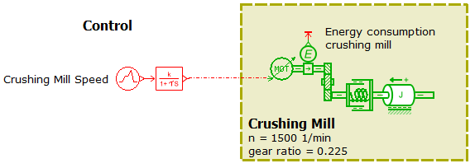  
  
*Figure 3 sketch of the crushing mill*

It consists of a simple control which induces a constant rotary speed between 5s and 10s. I added a first order lag just to prevent the system from giving peak values in torque for example. The motor icon transfers the signal into a physical value and applies it to the inertia. The ideal rotary mechanical gear reduces the speed by a factor of 0.225. A rotational spring/damper element is included to meet the causality requirements. The inertia sees some friction (Coulomb and viscous friction). An energy sensor also is included. The results from the model you can study below.

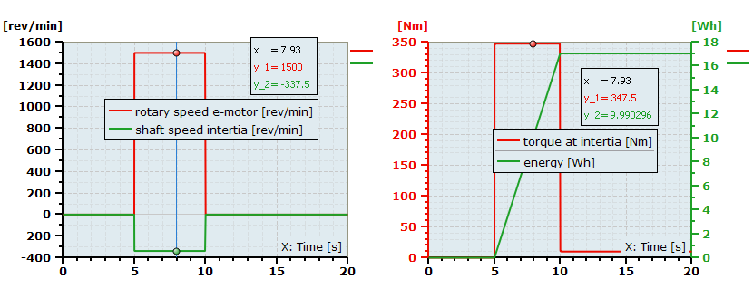  
*Figure 4 results from the crushing mill*

You simply can increase the complexity of the model by adding an electrical motor with voltage supply and speed control. This would be an approach to consider the dynamics of the motor and the heat generated in the motor. The temperature of the motor could be a process parameter which would have to be monitored.

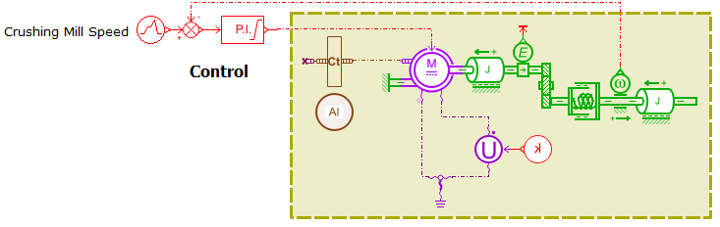  
*Figure 5 crushing mill driven by an electrical motor*

Here some exemplary results from this model.

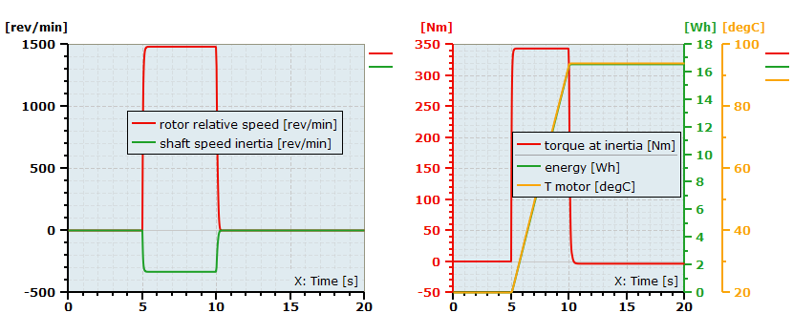  
*Figure 6 results from the enhanced crushing mill*